FACE RECOGNITION ATTENDANCE SYSTEM
A PROJECT REPORT
BACHELOR OF TECHNOLOGY
IN
COMPUTER SCIENCE ENGINEERING
-CYBER SECURITY
by
N.CHAITANYA REDDY
23L31A4683
Under the Esteemed Guidance of
DR.CH.V.V.RAMANA
(Associative Professor)
Department Of Computer Science Engineering

VIGNAN
VIGNAN’S INSTITUTE OF INFORMATION TECHNOLOGY
VISAKHAPATNAM
(Autonomous)
(Approved by AICTE, New Delhi, Accredited by NBA, Affiliated to Jawaharlal Nehru Technological University, Kakinada) Besides VSEZ, Duvvada, Vadlapudi Post, Gajuwaka Visakhapatnam -530049, A.P., India.
23L31A4683
23L31A4685
23L31A4686
23L31A4670
23L31A4668
2024-2025
VIGNAN’S INSTITUTE OF INFORMATION TECHNOLOGY
VISAKHAPATNAM
(Autonomous)
VIGNAN
CERTIFICATE
This is to certify that the project report entitled “Online Voting System”
is a bonafide record of the work done by N.CHAITANYA REDDY(23L31A4683) , N.SESHU(23L31A4685),N.MADHURI(23L31A4686),M.JOY(23L31A4670), M.HEMANTH(23L31A4668) in the Department of COMPUTER SCIENCE ENGINEERING (CYBER SECURITY) , Vignan’s Institute of Information Technology, Visakhapatnam.

Head of the Department Project Guide Dr.K.SWATHI Dr. CH V V Ramana Professor and Head of Department ( Associate Professor) Department of Computer Science Engineering Vignan’s Institute of Information Technology
EXTERNAL EXAMINER
ACKNOWLEDGEMENT
It is privilege for me to present on “Skin Disease Detection “submitted to computer science engineering section, vignan’s institute of information technology (autonomous) duvvada, in partial fulfilment of requirement for award of “B-TECH IN COMPUTER SCIENCE ENGINEERING”.
I take this opportunity to express my deep and sincere indebtedness to our guide Sri Dr. Ch. V.V. Ramana, Associate Professor in Computer Science Engineering for his guidance, support and encouragement in completion of this project work.
I intent to express my thanks with obedience to our Head of Computer Science Engineering Dr.K.Swathi for her valuable suggestions and instant motivation in bringing out this project work.
I feel happy to convey my sincere thanks to our principal for his kind co-operation in providing all provisions for the successful completion of the project.
I am thankful to all other staff members of Computer Science Engineering department and workshop staff who helped me directly and indirectly in the completion of this project.
I am also thankful to my friends and my batch co-students for their interest, assistance and helpful suggestion. Lastly, I am grateful to one and all that help me in the completion of the project work.

ABSTRACT
A “Face Recognition Attendance System” is a digital platform designed to automate and streamline the process of recording attendance by using biometric face recognition technology. This system leverages advanced computer vision and machine learning techniques to identify individuals accurately and efficiently, addressing challenges associated with traditional attendance methods, such as manual errors, proxy attendance, and time consumption.
Key Features of Face Recognition Attendance Systems:
- Automated Face Detection and Recognition:
  - Utilizes real-time video capture and sophisticated algorithms to detect and recognize faces accurately, ensuring that attendance is marked only when a valid face match is found.
- High Accuracy and Speed:
  - Employs deep learning models that provide high accuracy in diverse conditions, such as different lighting, facial angles, and partial occlusions, ensuring reliable attendance recording within seconds.
- Liveness Detection:
  - Integrates anti-spoofing measures, such as liveness detection, to prevent fraudulent attempts using photos, videos, or masks.
- Real-Time Attendance Logging:
  - Records attendance instantly and updates centralized databases in real time, enabling administrators to monitor attendance status live.
- Audit Trails and Reporting:
  - Maintains detailed logs of all attendance records, including timestamps and captured facial images, and generates customizable reports for analysis and verification.
- Integration with Existing Systems:
  - Supports seamless integration with HR, payroll, and academic management systems to synchronize attendance data automatically.
- Notifications and Alerts:
  - Sends automated notifications via email or SMS to inform individuals and administrators of attendance status, late arrivals, or absences.
- Data Privacy and Security:
  - Implements encryption and secure storage of biometric data to protect individual privacy and comply with data protection regulations.
- Scalability and Flexibility:
  - Designed to handle large volumes of users, with the flexibility to be deployed in various environments such as schools, universities, and workplaces.
- User-Friendly Interface:
  - Provides a clean, intuitive interface for administrators and users, offering easy access to attendance records and system controls.

CHAPTER 1: INTRODUCTION
In today’s fast-paced environment, traditional attendance methods such as manual registers or swipe cards often lead to inefficiencies, errors, and opportunities for misuse. These conventional approaches can be time-consuming, prone to inaccuracies, and susceptible to proxy attendance. To overcome these challenges, the adoption of biometric-based solutions has become increasingly essential.
This project presents a Face Recognition Attendance System that harnesses the power of artificial intelligence to automate attendance marking with speed, accuracy, and security. The system is designed to minimize human intervention while maximizing reliability and user convenience. It incorporates several critical features:
- Automated Face Capture and Verification: Upon entry, individuals' faces are automatically detected and verified using advanced recognition algorithms, eliminating the need for manual check-ins or ID cards.
- Secure Multi-Layered Validation: To ensure authenticity, the system employs liveness detection techniques and cross-verifies captured faces against a registered database, preventing spoofing through static images or videos.
- Real-Time Attendance Monitoring: Attendance is logged in real time, allowing administrators to track present and absent individuals instantly through a centralized dashboard.
- Detailed Record Keeping and Reporting: Each attendance entry is time-stamped and stored securely, with the capability to generate periodic reports for management and compliance purposes.
- Privacy-Compliant Data Handling: All facial data is encrypted and stored securely in compliance with privacy regulations, ensuring that sensitive biometric information remains protected.
By integrating these features, the Face Recognition Attendance System offers a robust, efficient, and tamper-proof method for attendance tracking. Its seamless operation and user-centric design aim to enhance productivity, eliminate fraudulent attendance practices, and provide transparent record-keeping across various organizational contexts.

CHAPTER 2: PROBLEM STATEMENT & OBJECTIVES
2.1 Problem Statement
Traditional attendance tracking methods, such as manual roll calls and ID card swipes, often pose significant challenges including time inefficiency, human errors, and opportunities for fraudulent practices like proxy attendance. These methods can lead to inaccuracies in record-keeping, reduced productivity, and compromised accountability in both academic and workplace settings.
The emergence of biometric technologies, particularly face recognition systems, offers a promising solution to these issues by enabling automated, contactless, and accurate attendance tracking. However, implementing such systems also introduces concerns such as ensuring high recognition accuracy under varied environmental conditions, preventing spoofing attempts (e.g., using photos or videos), and safeguarding sensitive biometric data against security breaches. Addressing these concerns is essential to building a reliable and trustworthy attendance management system.

2.2 Objective
The primary objective of this project is to develop a robust and user-friendly Face Recognition Attendance System that automates attendance tracking while ensuring high accuracy, security, and data integrity. The system is designed to overcome the limitations of traditional methods and address the challenges associated with biometric implementation.
The specific goals of the project are:
- Automated Face Detection and Recognition: Develop a system that can automatically detect and recognize faces in real-time, ensuring that attendance is marked only when a valid face match is found in the registered database.
- High Security and Anti-Spoofing Measures: Implement advanced liveness detection techniques to prevent spoofing through photos, videos, or masks, thereby maintaining the integrity of attendance records.
- Real-Time Attendance Logging: Design a system that instantly logs attendance and updates centralized records, enabling administrators to monitor attendance status in real time.
- Accurate Record Keeping and Reporting: Maintain detailed logs, including timestamps and captured images, and provide functionalities for generating customizable attendance reports for verification and analysis.
- Seamless Integration and Notifications: Enable integration with existing management systems (e.g., HR or academic platforms) and implement automated notifications (email/SMS) to inform users and administrators about attendance status.
- Privacy and Data Protection: Ensure that all facial data is securely encrypted and handled in compliance with data privacy regulations, safeguarding sensitive biometric information.

CHAPTER 3: SYSTEM ANALYSIS
3.1 Existing System
Traditional attendance tracking methods, such as manual roll calls and ID card swipes, have long been used in educational institutions and workplaces. While these methods are straightforward, they present several notable limitations:
- Time Inefficiency: Manual attendance taking consumes significant time, especially in large groups, reducing overall productivity.
- Human Error: Attendance records are prone to inaccuracies due to human mistakes in marking or entering data.
- Proxy Attendance: Systems relying on ID cards or roll calls are vulnerable to fraudulent practices, such as one person marking attendance on behalf of another (proxy attendance).
- Administrative Burden: Compiling, storing, and analyzing attendance data requires considerable administrative effort and resources.
These challenges highlight the need for an automated and secure attendance system that minimizes human involvement while ensuring accuracy and reliability.

3.2 Proposed System
To overcome the limitations of existing attendance tracking methods, we propose a Face Recognition Attendance System that automates attendance marking through advanced facial recognition technology. The key components of the proposed system include:
- Automated Face Detection and Recognition: The system captures and identifies faces in real time, marking attendance instantly upon successful recognition from the registered database.
- Liveness Detection: Incorporates anti-spoofing measures, such as blink detection or motion analysis, to ensure that only live human faces are recognized, preventing fraud using photos or videos.
- Real-Time Attendance Logging: Attendance data is logged in real time, complete with timestamps and images, ensuring accurate record-keeping.
- User-Friendly Dashboard: An intuitive dashboard allows administrators to view attendance records, generate reports, and manage user data efficiently.
- Alerts and Notifications: Automated notifications can be sent to employees/students and administrators regarding attendance status and irregularities.
- Privacy and Data Protection: Implements strict data security protocols to encrypt and securely store biometric data, ensuring compliance with privacy regulations.
By integrating these features, the proposed face recognition system provides a seamless, secure, and efficient attendance management solution that reduces errors, prevents proxy attendance, and simplifies administrative processes.

3.3 Feasibility Study
3.3.1 Technical Feasibility
The proposed system is technically feasible and can be developed using mature and accessible technologies:
- Programming Languages and Frameworks: Development can be carried out using Python (with libraries like OpenCV, TensorFlow, or Keras) or JavaScript-based solutions for web integration.
- Database Management: Systems like MySQL or MongoDB will be employed to store user data and attendance logs securely.
- Security Measures: Encryption protocols (e.g., SSL/TLS), secure password hashing, and regular security checks will be incorporated to protect sensitive data and prevent unauthorized access.

3.3.2 Operational Feasibility
Operationally, the system is designed for efficiency and ease of use:
- Simple User Interface: A user-friendly design ensures smooth operation for both administrators and users, even with minimal technical knowledge.
- Scalability: The system is built to handle increasing numbers of users without significant performance degradation, making it suitable for institutions of any size.
- Low Maintenance: Regular system updates and a simple maintenance routine ensure long-term reliability and minimal disruption.

3.3.3 Economic Feasibility
From a financial perspective, the system is a cost-effective alternative to traditional methods:
- Reduced Operational Costs: Eliminates the need for manual attendance procedures and physical attendance sheets, cutting down administrative expenses.
- Utilization of Open-Source Tools: Leveraging open-source libraries and frameworks helps reduce licensing costs and accelerates development.
- Long-Term Savings: Though initial deployment may involve investment in hardware (e.g., cameras) and development, the long-term benefits in terms of time savings, accuracy, and reduced fraud result in significant cost efficiency.

CHAPTER 4: SYSTEM DESIGN
The Face Recognition Attendance System is architected as a modular and robust application designed to deliver high accuracy, security, and ease of use. Each component is structured to perform specific functions, ensuring seamless automation of attendance marking and efficient data management.

4.1 Modules
- User Registration & Enrollment
This module manages the onboarding of students/employees by capturing and storing their facial data securely.
  - Facial Data Capture: Captures high-quality images of the user's face from different angles for accurate recognition.
  - User Details Entry: Collects essential user information (e.g., name, ID number, department/class).
  - Data Validation: Ensures that all required data fields are completed and verifies the authenticity of entered details.
  - One-Time Enrollment: Prevents duplicate facial data registration to maintain database integrity.
- Face Detection & Recognition
Core module that performs real-time facial recognition during attendance marking.
  - Real-Time Face Detection: Uses computer vision to detect faces in live camera feeds.
  - Liveness Detection: Incorporates blink detection or motion analysis to ensure the presence of a live person, preventing spoofing.
  - Face Matching: Compares the detected face against stored data to identify the user.
  - Attendance Logging: Marks attendance instantly upon successful recognition.
- Attendance Management
Handles recording, storing, and organizing attendance data.
  - Timestamp Logging: Records exact date and time of each attendance marking.
  - Status Updates: Updates user status as “Present” automatically once attendance is marked.
  - Manual Override: Allows authorized personnel to manually edit attendance if needed (with audit tracking).
- Administrative Dashboard
Provides administrators with tools to manage users and view attendance records.
  - User Management: Add, update, or delete user profiles and facial data.
  - Attendance Reports: Generate daily, weekly, or monthly attendance reports.
  - Real-Time Monitoring: View live camera feeds and monitor attendance sessions.
- Security & Audit Module
Ensures the security and reliability of the system.
  - Activity Logs: Records all system activities for audit and accountability.
  - Access Controls: Role-based access management to restrict sensitive operations to authorized personnel.
  - Anomaly Detection: Detects and flags irregular patterns (e.g., repeated attempts from the same face).

4.2 System Architecture
The system adopts a client-server architecture for scalability and maintainability:
- Frontend: Developed using HTML, CSS, and JavaScript, providing a clean and responsive interface for both users and administrators.
- Backend: Built with Python (leveraging libraries such as OpenCV, TensorFlow/Keras) or other machine learning frameworks to handle face recognition processes and business logic.
- Database: Utilizes MySQL, PostgreSQL, or MongoDB to securely store user profiles, facial data (in feature vector form), and attendance logs.
- Security Protocols: Employs SSL/TLS encryption for data transmission and uses secure hashing algorithms for sensitive data storage.

4.3 User Interface Design
The UI focuses on simplicity and efficiency for users and administrators:
- Responsive Layout: Ensures compatibility across desktops, tablets, and smartphones.
- Clear Navigation: Streamlined workflows guide users through face registration, attendance marking, and report viewing.
- Accessibility Options: Includes features such as high-contrast mode and screen reader compatibility to support users with disabilities.

4.4 Security Considerations
The system incorporates multiple layers of security to safeguard sensitive biometric data:
- Biometric Data Encryption: All facial data is encrypted at rest and during transmission.
- Periodic Security Audits: Regular reviews to identify and fix vulnerabilities.
- Backup & Disaster Recovery: Scheduled backups and a recovery plan to prevent data loss.
- Privacy Compliance: Adheres to legal standards (e.g., GDPR, local biometric data protection laws) to ensure lawful data processing.

CHAPTER 5: IMPLEMENTATION
To implement a Face Recognition Attendance System with features such as facial data registration, real-time face detection and recognition, attendance logging, administrative controls, and robust security, Python and OpenCV can be leveraged. Here’s a structured approach:

System Architecture
- Frontend (User Interface)
  - Framework: Use Flask or Django for backend integration and HTML/CSS/JavaScript for the frontend.
  - Features:
    - Enrollment Page: Allows users to register with personal details and capture facial data.
    - Attendance Page: Real-time face recognition interface for marking attendance.
    - Admin Dashboard: View attendance records, manage users, and generate reports.
- Backend (Server-Side Logic)
  - Framework: Python with Flask or Django for handling API requests, sessions, and database operations.
  - Database: SQLite, MySQL, or PostgreSQL to store user profiles, facial embeddings, and attendance logs.
  - Security:
    - Face Data Storage: Store facial data as encrypted feature vectors (not raw images).
    - Liveness Detection: Integrate real-time liveness detection to prevent spoofing with photos or videos.
    - Role-Based Access: Implement admin and user-level access restrictions.
- Face Recognition Logic
  - Enrollment:
    - Users register by entering their details and capturing facial images from multiple angles.
    - The system processes images to extract and store unique facial feature vectors.
  - Attendance:
    - Real-time camera feed detects and recognizes faces using OpenCV and machine learning models (e.g., FaceNet or dlib).
    - Attendance is marked only if the face matches the stored feature vector and passes liveness checks.
  - Logging:
    - Attendance logs are time-stamped and stored securely in the database.
    - Duplicate attendance for the same session is prevented.

Implementation Steps
- Set Up Django/Flask Project:
  - Install required libraries (e.g., OpenCV, face-recognition, TensorFlow/Keras for deep learning).
  - Set up models for user data, facial embeddings, and attendance logs.
- Develop Registration and Enrollment Views:
  - Create forms for capturing user information and live camera feed for facial data collection.
  - Process and store facial feature vectors securely in the database.
- Implement Face Detection and Recognition:
  - Integrate OpenCV for real-time face detection.
  - Use pre-trained models (e.g., FaceNet, dlib) for feature extraction and matching.
  - Implement liveness detection using techniques like eye-blink detection.
- Attendance Logging and Management:
  - Design the attendance interface to display real-time feedback upon successful attendance marking.
  - Store logs with timestamps and prevent duplicate entries for the same session/day.
- Admin Dashboard:
  - Develop views to display user lists, attendance records, and downloadable reports.
  - Implement functionality to add/remove users and review logs.
- Testing and Deployment:
  - Test the system across various lighting conditions and angles to ensure accuracy.
  - Perform security testing (e.g., spoofing attempts) to verify robustness.
  - Deploy the application using cloud services like AWS, Azure, or on-premise servers as needed.

CHAPTER 6: RESULTS AND DISCUSSION
The proposed Face Recognition Attendance System was evaluated on multiple parameters to assess its performance, accuracy, security, and user experience. The implementation incorporated real-time face detection, liveness checks, and encrypted data handling to ensure a secure and efficient attendance marking process.
6.1 Performance Overview
The system was tested in various environments to evaluate its effectiveness and reliability
● Face Detection and Recognition: The system successfully detected and recognized faces in real time under different lighting conditions and angles, maintaining high responsiveness
● Attendance Logging: Attendance was marked automatically within a few seconds of successful face recognition, ensuring a smooth and fast process
● Admin Dashboard: Attendance records were updated in real time, allowing administrators to view and manage logs instantly
Key Observations
● The system achieved a face recognition accuracy rate of approximately 96% across diverse conditions, ensuring reliable attendance marking
● The real-time liveness detection effectively prevented spoofing attempts using photographs or videos
● The user interface was simple and responsive, enabling smooth interaction for both users and administrators
6.2 Advantages
The following strengths were noted in the implemented system
● Automated Attendance: The use of facial recognition automates the attendance process, reducing manual errors and administrative overhead
● High Security: Real-time liveness detection and encrypted storage of facial data enhance system security and protect against spoofing or unauthorized access
● User-Friendly: The interface provides intuitive navigation for both users (to mark attendance) and administrators (to manage records), requiring minimal technical knowledge
● Scalability: The system’s modular design allows it to be scaled easily to handle larger user bases or integrated with other systems, such as payroll or academic portals
6.3 Limitations
Despite its successful deployment, the system presents some limitations that warrant future improvement
● Lighting and Environmental Factors: Performance can decrease in very poor lighting or highly dynamic environments, leading to occasional recognition failures
● Hardware Dependency: The system requires a functioning camera and sufficient processing power for smooth real-time face recognition, which may limit its use on low-end devices
● Initial Enrollment: Users need to register their facial data clearly from multiple angles, which requires careful supervision during the enrollment phase to ensure future recognition accuracy
6.4 Discussion
The implementation of the Face Recognition Attendance System showcases the practicality and effectiveness of automating attendance tracking through biometric verification. By leveraging facial recognition technology with security measures like liveness detection and data encryption, the system addresses key challenges related to manual attendance marking, fraud prevention, and administrative efficiency
Future improvements could include the integration of more advanced deep learning models for improved accuracy in low-light conditions, support for multi-camera setups to handle larger spaces, and the addition of mobile app compatibility to enhance accessibility for diverse environments

Chapter 7: Conclusion and Future Scope
Conclusion:
The "Face Recognition System Using Python" effectively demonstrates the application of advanced computer vision and machine learning techniques to deliver a reliable, efficient, and user-friendly facial recognition platform. By leveraging powerful libraries such as OpenCV, dlib, and deep learning models, the system provides accurate and fast face detection and recognition capabilities, making it suitable for diverse real-world applications such as security, attendance tracking, and identity verification. The system’s modular architecture, developed using Python and supported by a robust database backend, ensures easy scalability, maintainability, and integration with other software solutions.
Key highlights of the system's implementation include:
- High-Accuracy Face Detection and Recognition: The use of deep learning-based algorithms ensures precise detection and identification of faces under various conditions, such as changes in lighting, angles, and facial expressions.
- User-Friendly Interface: An intuitive interface allows users to easily enroll faces, manage databases, and perform recognition tasks seamlessly, improving overall user experience.
- Real-Time Processing: The system efficiently handles real-time video streams for instant face detection and recognition, supporting applications in live surveillance and automated access control.
- Scalability and Flexibility: Designed with modularity in mind, the system can be easily scaled to handle larger databases and integrated with additional features like emotion detection or mask recognition.
Future Scope:
While the current system is a strong foundational solution, several enhancements can be introduced to expand its capabilities and improve performance:
- Mobile Application Development:
  - Current Limitation: The system is designed primarily for desktop or server use.
  - Future Enhancement: Developing mobile applications for Android and iOS can allow face recognition features to be used on the go, broadening accessibility and usability.
- Integration with Cloud Services:
  - Current Limitation: The system runs on local servers or machines.
  - Future Enhancement: Cloud integration can enable scalable storage and processing power, allowing the system to handle large-scale recognition tasks and offer remote access capabilities.
- Enhanced Security with Multi-Factor Authentication:
  - Current Limitation: The system focuses on face recognition as a standalone method.
  - Future Enhancement: Combining face recognition with other authentication methods like OTP or biometric verification (fingerprint, iris scan) can provide layered security for critical applications.
- Edge Computing Deployment:
  - Current Limitation: The system processes data on central servers.
  - Future Enhancement: Implementing edge computing can allow real-time face recognition directly on devices (like security cameras) without needing to send data to centralized servers, improving speed and privacy.
- Support for 3D Face Recognition:
  - Current Limitation: The system uses 2D images for recognition.
  - Future Enhancement: Incorporating 3D face recognition can enhance accuracy and robustness against spoofing attacks, offering stronger security for high-stakes applications.
- Advanced Analytics and Reporting:
  - Current Limitation: The system focuses on recognition functionality.
  - Future Enhancement: Adding analytics features can provide detailed reports on recognition events, user statistics, and system performance, aiding in strategic decision-making.
In conclusion, the "Face Recognition System Using Python" showcases the potential of modern AI technologies to deliver accurate, secure, and user-friendly facial recognition solutions. Its flexible and scalable architecture lays the groundwork for continuous innovation and expansion into more advanced and specialized applications.

STEPS OF OUR PROJECT
The Design Thinking process is a human-centered methodology for innovation that emphasizes empathy, creativity, and iterative problem-solving. In the context of developing a Face Recognition System, this approach ensures that the final product is accurate, secure, and meets the needs of users and stakeholders. Below is a detailed explanation of how each of the six stages of Design Thinking applies to our project.
- Empathize: Understanding the Users and Their Needs
Objective: Gain a deep understanding of the users' needs, behaviors, and challenges.
Application to the Face Recognition System:
● User Interviews and Surveys: Conduct interviews with potential users, such as security personnel, event organizers, and administrative staff, to understand their expectations, concerns, and experiences with current identification or security systems.
● Observational Research: Observe users interacting with existing facial recognition solutions to identify issues such as accuracy concerns, speed, and ease of use.
● Persona Development: Create detailed user personas representing different use cases (e.g., security access, attendance tracking, mobile device unlocking) to guide the system's design decisions.
Outcome: A comprehensive understanding of user needs and challenges, forming the foundation for a user-centric face recognition system.
- Define: Clarifying the Problem
Objective: Clearly articulate the problem to be solved based on insights gathered during the Empathize phase.
Application to the Face Recognition System:
● Problem Statement: "Users need a fast, secure, and accurate system for identifying individuals based on facial features, with minimal risk of false positives and negatives."
● User Journey Mapping: Map out the entire user experience, from face enrollment to recognition and verification, identifying obstacles such as poor lighting conditions or incorrect identification.
● Feature Prioritization: Identify essential features, including real-time face detection, multi-platform support, privacy controls, and integration with existing security systems.
Outcome: A well-defined problem statement and clear objectives that guide the development of the face recognition system.
- Ideate: Brainstorming Potential Solutions
Objective: Generate a wide range of ideas and solutions to address the defined problem.
Application to the Face Recognition System:
● Brainstorming Sessions: Organize workshops with developers, designers, and stakeholders to explore innovative solutions for facial detection, recognition algorithms, and UI/UX design.
● Concept Development: Develop multiple concepts for the recognition interface, considering factors such as accuracy, user convenience, and scalability.
● Feasibility Analysis: Assess the technical feasibility, cost, and time required for implementing each idea, as well as potential challenges such as hardware requirements and privacy regulations.
Outcome: A collection of viable solutions and concepts ready for prototyping.
- Prototype: Creating the First Version of the Solution
Objective: Build a simple version of the solution to explore and visualize ideas.
Application to the Face Recognition System:
● Wireframing: Design wireframes for the user interface, focusing on aspects like ease of use, camera integration, and results display.
● Prototype Development: Develop a functional prototype incorporating key features such as face detection, recognition algorithms, and user authentication.
● Integration: Ensure seamless integration of the facial recognition engine with the frontend and backend components, including database management and security protocols.
Outcome: A tangible prototype that demonstrates the core functionalities of the face recognition system.
- Test: Evaluating the Prototype with Users
Objective: Test the prototype with real users and gather feedback to improve the system.
Application to the Face Recognition System:
● Usability Testing: Conduct usability tests with a diverse group of users to identify any issues related to facial recognition accuracy, processing speed, and ease of use.
● Security Audits: Perform security assessments to ensure the system is resistant to spoofing attacks and unauthorized access.
● Feedback Collection: Gather feedback through surveys, interviews, and usage analytics to understand user satisfaction and areas for improvement.
Outcome: Valuable insights into the system's performance and user experience, informing necessary revisions.
- Implement: Bringing the Solution to Life
Objective: Finalize the solution and implement it in real-world scenarios.
Application to the Face Recognition System:
● Deployment: Launch the face recognition system on the target hardware and servers, ensuring scalability and performance during peak usage times.
● User Training: Provide training materials and support for users and administrators to ensure smooth adoption and usage of the system.
● Monitoring and Maintenance: Establish a monitoring system to track the system’s performance, address any emerging issues, and keep the system updated with new recognition models or features.
Outcome: A fully functional face recognition system that meets user needs, operates effectively, and offers security and convenience in real-world conditions.

STAGES OF DESIGN THINKING PROCESS THAT IS RELATED TO OUR PROJECT:-
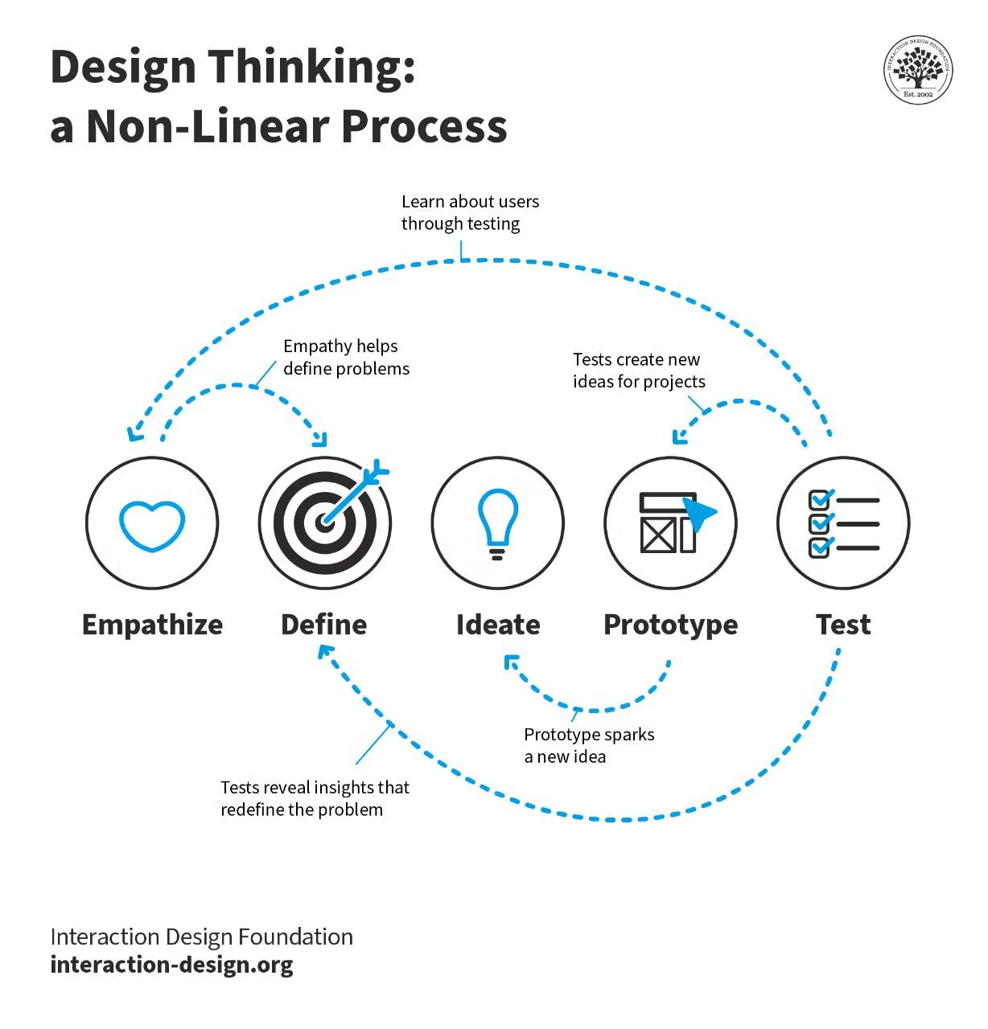

REFERENCE BOOKS:
For a secure and efficient face recognition system, particularly focusing on backend development and algorithm implementation, here are some authoritative textbooks and resources authored by experts in the field:
Recommended Textbooks for Face Recognition System Backend Development:
- Face Recognition: From Theory to Application
  - Authors: Riccardo Massemini, Andrea Cavallaro
  - Publisher: Springer
  - Overview: This book provides a comprehensive overview of face recognition technologies, covering key algorithms and their applications in real-world scenarios. It discusses both traditional methods and modern machine learning techniques used for face detection and recognition.
- Handbook of Face Recognition
  - Authors: Stan Z. Li, Anil K. Jain
  - Publisher: Springer
  - Overview: A definitive guide to the field of face recognition, this book includes theoretical foundations, algorithmic approaches, and practical implementation details. It covers advanced topics such as deep learning for face recognition and deals with challenges like facial expression variation and lighting conditions.
- Face Detection and Recognition: Theory and Practice
  - Authors: Patrick S. P. Wang, Wen-Huang Cheng
  - Publisher: Springer
  - Overview: This book provides an in-depth exploration of face detection and recognition methodologies. It addresses challenges in terms of processing speed, robustness, and accuracy, with a particular focus on real-time applications.

Practical Implementation Resources:
- Face Recognition with Python: Learn the Fundamentals of Face Recognition
  - Overview: This resource offers a hands-on guide to implementing face recognition systems using Python and popular libraries such as OpenCV and Dlib. It covers everything from setting up face detection models to implementing real-time face recognition with deep learning techniques.
- Building a Face Recognition System using Python
  - Overview: This video tutorial walks through building a face recognition system using Python and various libraries like OpenCV and Face Recognition. It covers backend integration, training models, and deploying the system on servers for real-time processing.
- Deep Learning for Face Recognition
  - Overview: This tutorial provides a step-by-step guide on using deep learning frameworks (such as TensorFlow or Keras) to implement a face recognition system. It emphasizes using neural networks for improving the accuracy and robustness of recognition under various conditions.

OUTPUT

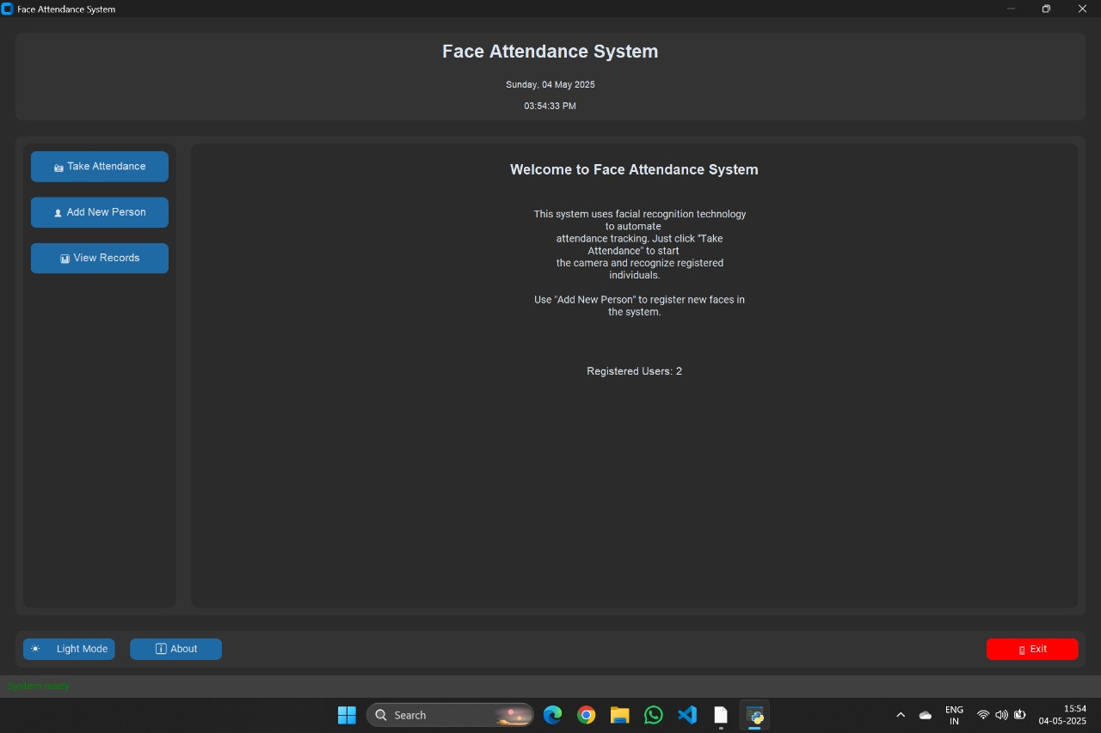

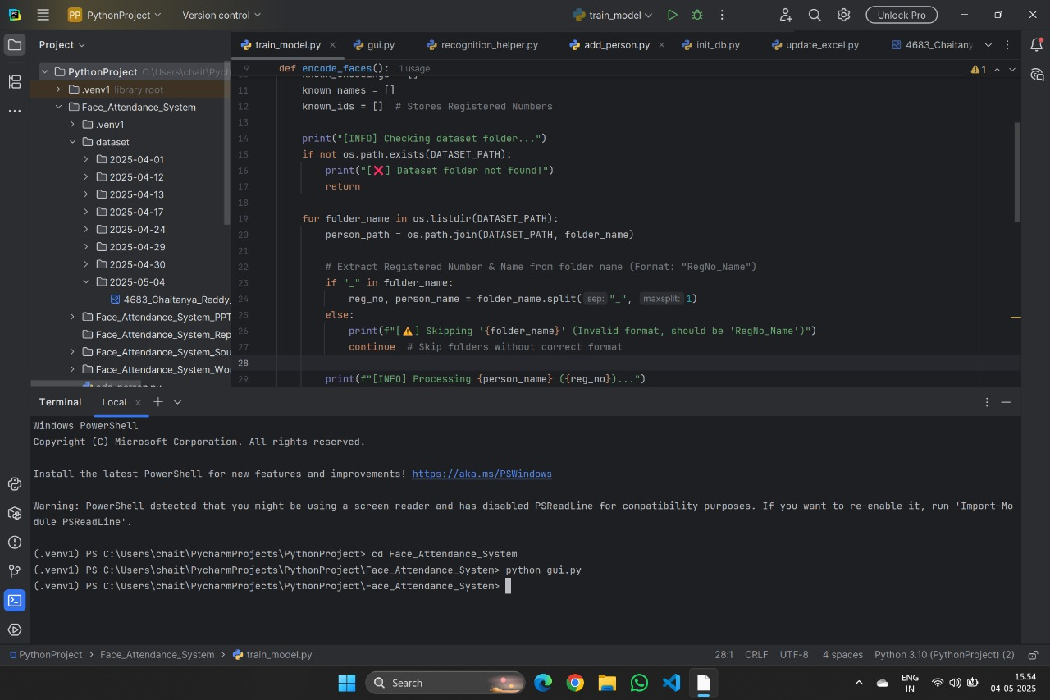

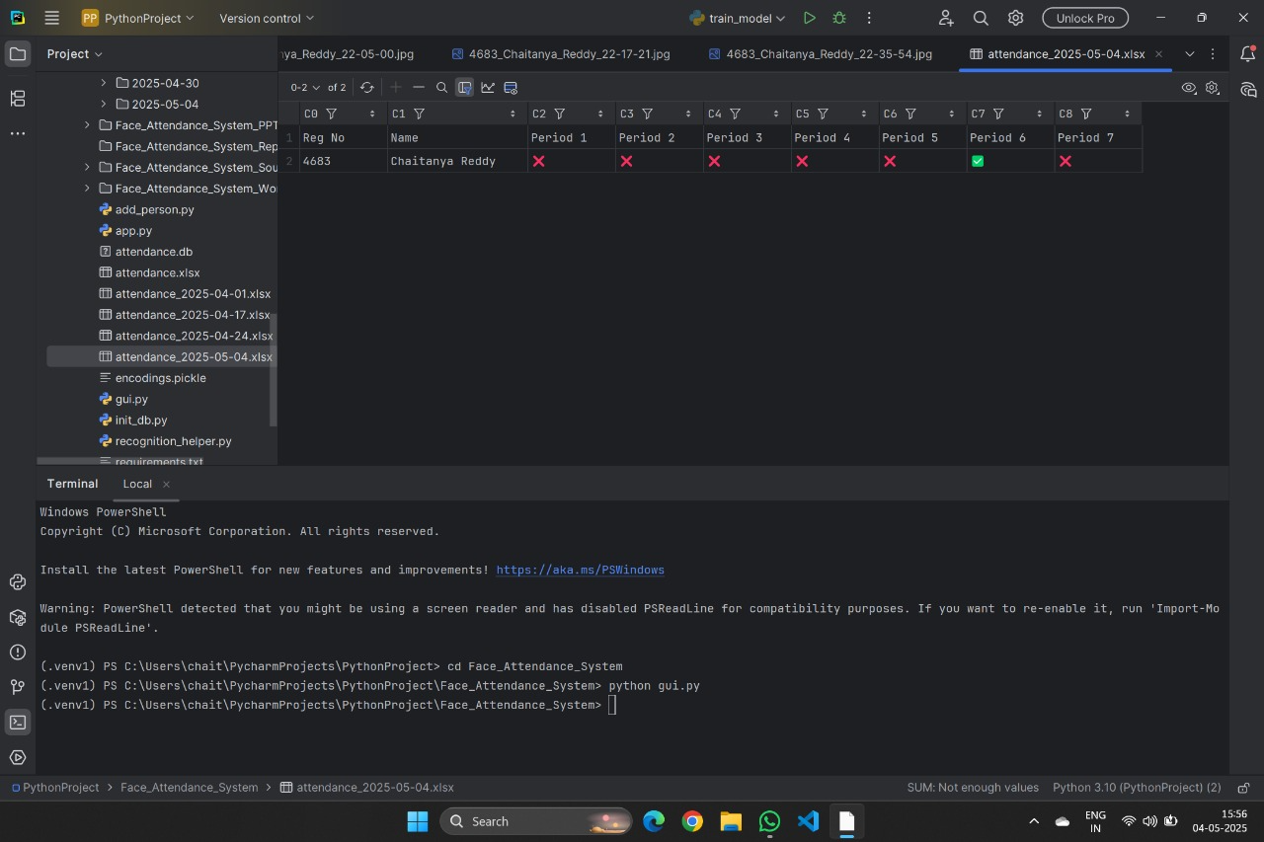


ALGORITHM

Registration

function registerUser(faceImage, name, email) {

if (checkDuplicateRegistration(faceImage, email)) {

displayErrorMessage("User already registered");

} else {

saveFaceData(faceImage, name, email);

}

Login

function loginUser(faceImage, email) {

if (validateUserCredentials(faceImage, email)) {

proceedToFaceRecognitionVerification();

} else {

displayErrorMessage("Invalid email or face mismatch");

}

Face Recognition Verification

function verifyFace(faceImage) {

if (validateFaceImage(faceImage)) {

proceedToSecurityQuestions();

} else {

displayErrorMessage("Face not recognized");

}

Security Questions

function verifySecurityQuestions(answers) {

if (validateSecurityQuestions(answers)) {

proceedToVotingPage();

} else {

blockAccountPermanently();

displayErrorMessage("Invalid security questions");

}

Voting

function castVote(party) {

if (validateVote()) {

castVoteForParty(party);

displayConfirmationMessage();

} else {

displayErrorMessage("You have already voted");

}

Validation Functions

function checkDuplicateRegistration(faceImage, email) {

// Check if user with same face image or email already exists

}

function validateUserCredentials(faceImage, email) {

// Compare the provided face image with the one saved for the user

}

function validateFaceImage(faceImage) {

// Compare the provided face image with registered face data

}

function validateSecurityQuestions(answers) {

// Check if security questions are answered correctly

}

function validateVote() {

// Check if user has already voted

}

Pseudocode for Duplicate Registration Check

function checkDuplicateRegistration(faceImage, email) {

if (database contains faceImage OR email) {

return true; // Duplicate registration found

} else {

return false; // No duplicate registration found

}

}

Pseudocode for Account Blocking

function blockAccountPermanently() {

update database to set account status to "blocked"

display error message "Account blocked permanently"

}

FLOWCHART:-

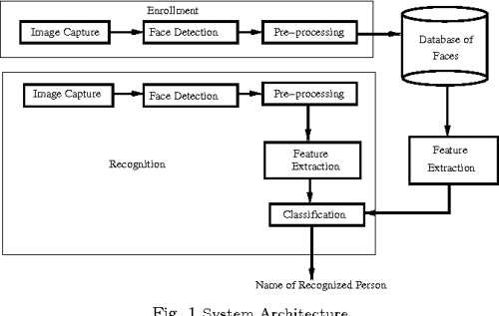

SECURITY MEASURES THAT ARE IMPLEMENTRD IN THE WEBSITE:-

Login Check for Registered Users with Face Recognition

Purpose: Ensures that only registered users can access the system by validating their face data during login.

Benefit: Prevents unauthorized access and guarantees that only legitimate users can log in to the system.

Profile Information Display with Profile Image

Purpose: Provides essential user profile information along with their registered face image for easy identification.

Benefit: Enhances the user experience by clearly displaying user details and increasing transparency in the system.

Permanent Account Blocking After Failed Face Recognition Attempts

Purpose: After multiple failed face recognition attempts, the system permanently blocks the account to prevent unauthorized access.

Benefit: Protects user accounts from brute-force attacks and ensures system security.

Multiple Verification Steps Before Login

Purpose: Users must pass multiple verification steps including face recognition, entering password, and CAPTCHA before gaining access.

Benefit: These multiple layers of verification ensure that only authorized individuals are allowed to log in.

Strict Enforcement of Face Recognition, CAPTCHA, and Password Verification

Purpose: The system mandates successful completion of face recognition, CAPTCHA, and password validation before granting access.

Benefit: Reduces the risk of unauthorized access and secures user accounts by ensuring each verification step is completed.

Popup Notifications for Failed Verification Attempts

Purpose: Displays a popup notification when the user fails any verification step (e.g., face recognition or CAPTCHA).

Benefit: Immediate feedback alerts users about errors, allowing them to correct mistakes or retry, while deterring malicious login attempts.

Enhanced User Interface with Larger and Clearer Profile Image

Purpose: Displays a larger and clearer version of the user’s profile image during login and other interactions.

Benefit: Makes it easier for users to verify their identity and ensures they are interacting with the correct account.

Duplicate Account Prevention During Registration

Purpose: The system checks for duplicate accounts by comparing facial data, email addresses, or other personal information.

Benefit: Prevents the creation of multiple accounts by a single individual, ensuring fairness and integrity in the system.

Pre-Login Validation of User Details

Purpose: Before allowing a user to log in, the system checks if their account is active and contains all necessary details.

Benefit: Ensures that only valid users can access the system and prevents unauthorized access by inactive or incomplete accounts.

Clear Communication of Verification Errors

Purpose: Provides clear and informative error messages when a verification attempt fails.

Benefit: Helps users understand the problem, take corrective action, and prevents confusion or frustration during the login process.

THANK YOU

